**SMART PUBLIC RESTROOM­-Phase 5**

**INTRODUCTION:**

Smart public restrooms represent a modern and innovative approach to addressing the needs of individuals when it comes to public sanitation. These facilities go beyond the conventional restroom experience by integrating advanced technologies and design principles to provide improved hygiene, accessibility, and user comfort. Smart public restrooms are becoming increasingly important in urban environments, transportation hubs, and public spaces, where efficient, clean, and user-friendly restroom facilities are in high demand.

**1. Enhanced Hygiene :** IoT technology allows for the implementation of touchless fixtures, automatic sanitization systems, and real-time cleanliness monitoring. This leads to a significant improvement in restroom hygiene, reducing the risk of infection transmission.

**2. Optimized Resource Management :** The project aims to optimize resource utilization through sensors that monitor restroom traffic, water and energy consumption, and waste management. This ensures that resources are used efficiently and minimizes operational costs.

**3. User Convenience :** Smart public restrooms will feature advanced features such as touchless entry, occupancy indicators, and digital signage for user guidance. These conveniences make the restroom experience more pleasant and user-friendly.

**4. Sustainability :** The project also emphasizes sustainability by promoting water and energy conservation, the use of eco-friendly materials, and the incorporation of renewable energy sources.

**5. Real-time Data and Analytics :** IoT sensors and devices within these restrooms collect and transmit data in real-time. This data can be analyzed to make informed decisions about maintenance, user patterns, and resource allocation.

**6. Accessibility and Inclusivity :** Smart public restrooms are designed with inclusivity in mind, offering features like accessible stalls, baby-changing facilities, and language options on digital interfaces to cater to diverse user needs.

**7. Security and Safety :** The project ensures the safety and security of users through the implementation of surveillance systems, emergency alert buttons, and occupancy monitoring.

**8. Smart Maintenance :** Predictive maintenance is a key component of the project, with IoT sensors detecting issues before they become major problems, reducing downtime, and improving the overall restroom experience.

**9. Community Feedback Integration :** Public input is valuable in maintaining and enhancing these facilities. The project will incorporate feedback mechanisms, allowing users to report issues and suggest improvements through digital interfaces or mobile apps.

**DESCRIPTION:**

**1. Hygiene and Sanitation:** Smart public restrooms prioritize cleanliness and hygiene. Features such as touchless fixtures (faucets, soap dispensers, and hand dryers), automatic flush toilets, and antimicrobial surfaces reduce the risk of contamination and help maintain a germ-free environment.

**2. Accessibility:** These restrooms are designed to be inclusive, providing accessibility features for individuals with disabilities, such as spacious stalls, grab bars, and audio or visual cues for the visually impaired. The goal is to ensure that all users can access and use the facilities comfortably.

**3. Resource Efficiency:** Smart public restrooms are environmentally conscious. They often incorporate water-saving technologies like low-flow toilets, waterless urinals, and energy-efficient lighting. Occupancy sensors help reduce water and energy consumption by activating lighting and ventilation only when the restroom is in use.

**4. Real-time** **Information:** To improve the user experience, these facilities may provide real-time information about restroom availability through mobile apps or digital displays. Users can quickly locate the nearest available restroom, reducing waiting times and frustration.

**5. Safety and Security:** Some smart public restrooms are equipped with surveillance cameras to enhance user safety. Emergency call buttons may also be available for users to summon assistance in case of accidents or security concerns.

**6. Maintenance and Cleaning Optimization**: Smart sensors monitor restroom traffic and usage patterns, enabling predictive maintenance and efficient cleaning schedules. This data-driven approach ensures that resources are utilized effectively and that the restroom remains in optimal condition.

**7. Privacy and Comfort:** The restroom layout and design prioritize user comfort and privacy. Soundproofing, proper ventilation, high-quality fixtures, and aesthetically pleasing interiors contribute to a more pleasant experience.

**8. Sustainability and Green Practices:** Smart public restrooms often incorporate sustainable and environmentally friendly design principles, using eco-friendly materials and promoting water and energy conservation. These practices help reduce the environmental impact of the facility.

**IOT DEVICES:**

**1. Occupancy Sensors :** These sensors can detect when a restroom stall is in use or vacant, helping users locate available facilities and aiding in efficient restroom maintenance.

**2. Flush Sensors :** IoT-enabled flush sensors can control the water usage by adjusting flush volumes based on the type of use. They can also detect and report toilet malfunctions in real-time.

**3. Water Quality Sensors :** These sensors monitor the quality of water in sinks and urinals, ensuring it meets safety and hygiene standards.

**4. Soap and Hand Sanitizer Dispensers :** IoT dispensers can monitor the level of soap or hand sanitizer and trigger refills when necessary, reducing waste and ensuring a constant supply.

**5. Air Quality Sensors :** Monitoring air quality can help maintain a comfortable and healthy restroom environment. These sensors can detect and manage ventilation, temperature, and humidity.

**6. Touchless Faucets and Soap Dispensers :** These devices reduce the risk of contamination and also contribute to water conservation.

**7. Toilet Seat Sanitization Systems :** These systems can automatically sanitize toilet seats after each use.

**8. Waste Bin Sensors :** IoT sensors in waste bins can signal when they need to be emptied, optimizing the maintenance schedule and preventing overflow.

**9. Security Cameras :** Surveillance cameras can enhance safety and security within the restroom. They can also help in monitoring cleanliness and identifying vandalism.

**10. Emergency Alert Buttons :** These IoT buttons can be installed in restrooms for users to call for assistance in case of emergencies.

**11. Digital Signage and Feedback Kiosks :** Interactive screens can provide information to users, show occupancy data, and allow users to provide feedback or report issues.

**12. Smart Locks :** IoT-enabled locks can provide secure and touchless access control to restroom facilities.

**13. Energy Monitoring Sensors :** These sensors can measure energy consumption, such as lighting and heating, and help optimize energy efficiency.

**14. Smart Mirrors :** Smart mirrors can display information such as news, weather, or occupancy status, making the restroom experience more informative and enjoyable.

**15. Mobile Apps :** Developing a mobile app for users to find nearby smart public restrooms, check real-time availability, and provide feedback can enhance the project's user engagement.

**16. Noise Sensors :** These sensors can monitor noise levels in the restroom, ensuring a peaceful and comfortable environment.

**17. Language Selection Interfaces : Digital** interfaces that allow users to select their preferred language for restroom instructions and information.

**18. Renewable Energy Sources :** Solar panels and wind turbines can be integrated to provide sustainable energy for IoT devices and restroom infrastructure.

**DEVICE SETUP:**

**1. Smart Locks and Access Control :**

- Install smart locks on the restroom doors to control access.

- These locks can be controlled via a central system or mobile app, allowing users to gain access when necessary.

**2. Occupancy Sensors :**

- Install occupancy sensors above each restroom stall.

- These sensors should communicate with a central control system to display stall availability on digital signage.

**3. Flush Sensors :**

- Attach flush sensors to the toilet fixtures.

- Set up the system to adjust flush volume based on use or detect toilet malfunctions.

**4. Water Quality Sensors :**

- Place water quality sensors in sinks and urinals.

- Connect them to a monitoring system to ensure water quality meets hygiene standards.

**5. Soap and Hand Sanitizer Dispensers :**

- Install IoT-enabled dispensers with level sensors for soap and hand sanitizer.

- Link them to the central system for automated refills and monitoring.

**6. Air Quality Sensors :**

- Place air quality sensors in the restroom to monitor temperature, humidity, and air quality.

- Connect them to the ventilation system to maintain a comfortable environment.

**7. Toilet Seat Sanitization Systems :**

- Install systems that automatically sanitize toilet seats between uses.

**8. Waste Bin Sensors :**

- Place waste bin sensors in each trash receptacle.

- Connect them to a central system to schedule efficient waste removal.

**9. Security Cameras :**

- Install surveillance cameras at strategic locations within the restroom for security and cleanliness monitoring.

- Ensure cameras are positioned for user privacy and legal compliance.

**10. Emergency Alert Buttons :**

- Position emergency alert buttons in easily accessible locations.

- Connect them to the central monitoring system for immediate response to user requests.

**11. Digital Signage and Feedback Kiosks :**

- Set up digital signage displays near the restroom entrance, displaying occupancy data and other relevant information.

- Install feedback kiosks that allow users to report issues or provide feedback.

**12. Energy Monitoring Sensors :**

- Install sensors to monitor energy consumption of lighting, heating, and other electrical systems.

- Connect these sensors to an energy management system for optimization.

**13. Noise Sensors :**

- Position noise sensors in the restroom to monitor noise levels.

- Configure them to provide feedback to the central control system.

**14. Smart Mirrors and Language Selection Interfaces :**

- Install smart mirrors with integrated digital displays and language selection interfaces.

**15. Renewable Energy Sources :**

- Integrate solar panels and wind turbines on the restroom's exterior to provide sustainable energy for IoT devices and infrastructure.

**16. Mobile App :**

- Develop a user-friendly mobile app that provides real-time restroom information, including availability, cleanliness, and user feedback features.

**17. Central Control System :**

- Implement a centralized control system that manages all IoT devices, collects data, and coordinates operations.

- This system should be able to analyze data, trigger maintenance alerts, and display information on digital signage.

**18. Network Connectivity :**

- Ensure the restroom has a reliable network connection to transmit data from IoT devices to the central control system.

**19. Maintenance and Support :**

- Establish a maintenance plan to ensure all IoT devices function correctly, including regular software updates and equipment checks.

**PLATFORM DEVELOPMENT:**

**1. Project Planning and Requirements Analysis :**

- Define the objectives and requirements of the platform.

- Identify key stakeholders and their roles in the project.

- Create a project roadmap and timeline.

**2. Technology Stack Selection :**

- Choose the appropriate technology stack for the platform, including backend and frontend technologies.

- Consider the scalability, security, and compatibility of the selected stack.

**3. Backend Development :**

- Develop the backend infrastructure to manage and process data from IoT devices.

- Implement data storage, data processing, and analytics capabilities.

- Set up APIs for communication with IoT devices and mobile apps.

**4. Database Design :**

- Design a database schema to store data from IoT devices, user feedback, and other relevant information.

- Consider using a relational or NoSQL database depending on the data structure and requirements.

**5. User Interface Design :**

- Create a user-friendly interface for administrators, maintenance personnel, and end-users.

- Design the interface for web-based access and the mobile app.

**6. Real-time Data Processing :**

- Implement real-time data processing to monitor device statuses, occupancy, water and energy consumption, air quality, and more.

- Set up alerts for system administrators in case of issues or maintenance requirements.

**7. IoT Device Integration :**

- Integrate the IoT devices into the platform using IoT protocols like MQTT or HTTP.

- Ensure secure and reliable communication with the devices.

**8. User Engagement Features :**

- Develop features for users, such as a mobile app with restroom location finding, real-time availability status, and user feedback submission.

- Implement a feedback system for users to report issues, provide suggestions, and rate restroom cleanliness.

**9. Security :**

- Implement robust security measures to protect data and user privacy.

- Use encryption, authentication, and access controls to safeguard the platform.

**10. Scalability :**

- Design the platform to be scalable, allowing for the addition of more restrooms and devices as the project expands.

**11. Cloud Integration :**

- Consider integrating with cloud services for scalability and data storage.

- Use cloud-based analytics and machine learning for data insights.

**12. Localization and Multilingual Support :**

- Incorporate language selection features for the digital interfaces.

- Ensure that the platform supports multiple languages to cater to a diverse user base.

**13. Testing and Quality Assurance :**

- Conduct rigorous testing, including functional, security, and load testing, to identify and fix any issues.

- Ensure the platform operates as expected and meets all requirements.

**14. Documentation and Training :**

- Create comprehensive documentation for system administrators and users.

- Provide training to personnel responsible for managing and maintaining the system.

**15. Deployment and Monitoring :**

- Deploy the platform in the restroom facilities and data center.

- Implement monitoring tools to ensure the system runs smoothly and is always available.

**16. Maintenance and Support :**

- Establish a plan for ongoing maintenance, updates, and technical support.

- Set up mechanisms for reporting and resolving issues.

**17. User Feedback Loop :**

- Continuously analyze user feedback data to improve the system, address issues, and enhance the user experience.

**18. Data Analytics and Reporting :**

- Implement data analytics and reporting tools to derive insights from restroom usage, resource consumption, and user behavior.

**CODE IMPLEMENTATION:**

**1. IoT Device Code:**

**PYTHON:**

# Sample code for an occupancy sensor (Python)

import random

import paho.mqtt.client as mqtt

def simulate_occupancy():

# Simulate occupancy data

return random.choice([True, False])

def publish_occupancy_data():

client = mqtt.Client()

client.connect("mqtt-broker-url", 1883)

while True:

occupancy = simulate_occupancy()

client.publish("restroom/occupancy", str(occupancy))

time.sleep(5) # Publish data every 5 seconds

if __name__ == "__main__":

publish_occupancy_data()

**2. Backend Code (Python with Flask framework) :**

**PYTHON:**

from flask import Flask, request, jsonify

app = Flask(__name__)

@app.route("/api/occupancy", methods=["POST"])

def update_occupancy():

data = request.get_json()

# Process occupancy data and update the database

return jsonify({"message": "Occupancy data updated successfully"})

@app.route("/api/feedback", methods=["POST"])

def collect_feedback():

data = request.get_json()

# Process user feedback and store it in the database

return jsonify({"message": "User feedback received"})

if __name__ == "__main__":

app.run(debug=True)

**3. Database Configuration (SQLite) :**

**PYTHON**:

import sqlite3

# Create a SQLite database connection

conn = sqlite3.connect("smart_restroom.db")

cursor = conn.cursor()

# Define database schema and create tables

cursor.execute("""

CREATE TABLE IF NOT EXISTS occupancy (

id INTEGER PRIMARY KEY,

timestamp DATETIME,

status BOOLEAN

)

""")

cursor.execute("""

CREATE TABLE IF NOT EXISTS feedback (

id INTEGER PRIMARY KEY,

timestamp DATETIME,

message TEXT

)

""")

conn.commit()

conn.close()

```

**4. Frontend Code (HTML, CSS, and JavaScript) :**

**- HTML for a feedback form:**

**HTML:**

<form id="feedback-form">

<label for="feedback">Please provide your feedback:</label>

<textarea id="feedback" name="feedback" rows="4" cols="50"></textarea>

<input type="submit" value="Submit Feedback">

</form>

**- JavaScript for submitting feedback:**

**JAVASCRIPT:**

document.getElementById("feedback-form").addEventListener("submit", function (event) {

event.preventDefault();

const feedback = document.getElementById("feedback").value;

// Send feedback data to the backend via an API call

fetch("/api/feedback", {

method: "POST",

headers: {

"Content-Type": "application/json"

},

body: JSON.stringify({ feedback })

})

.then((response) => response.json())

.then((data) => {

alert(data.message);

})

.catch((error) => {

console.error(error);

});

});

**DIAGRAM:**

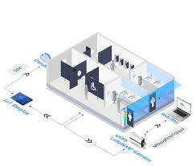

**SCHEMATIC DIAGRAM:**

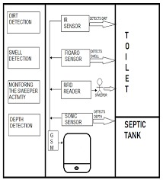

**CIRCUIT DIAGRAM:**

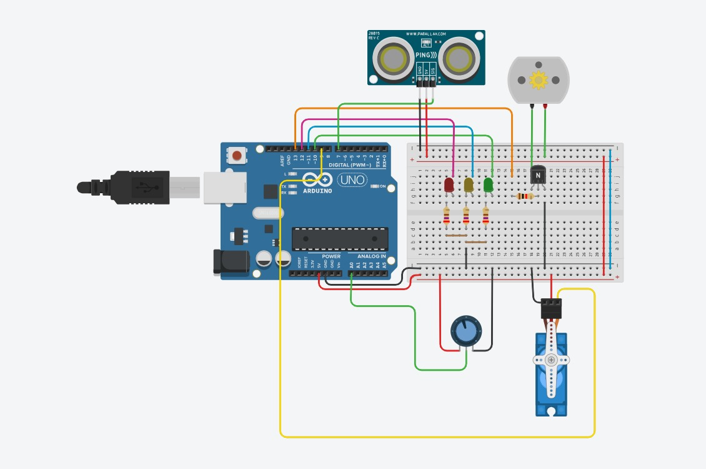

**SCREENSHOT:**

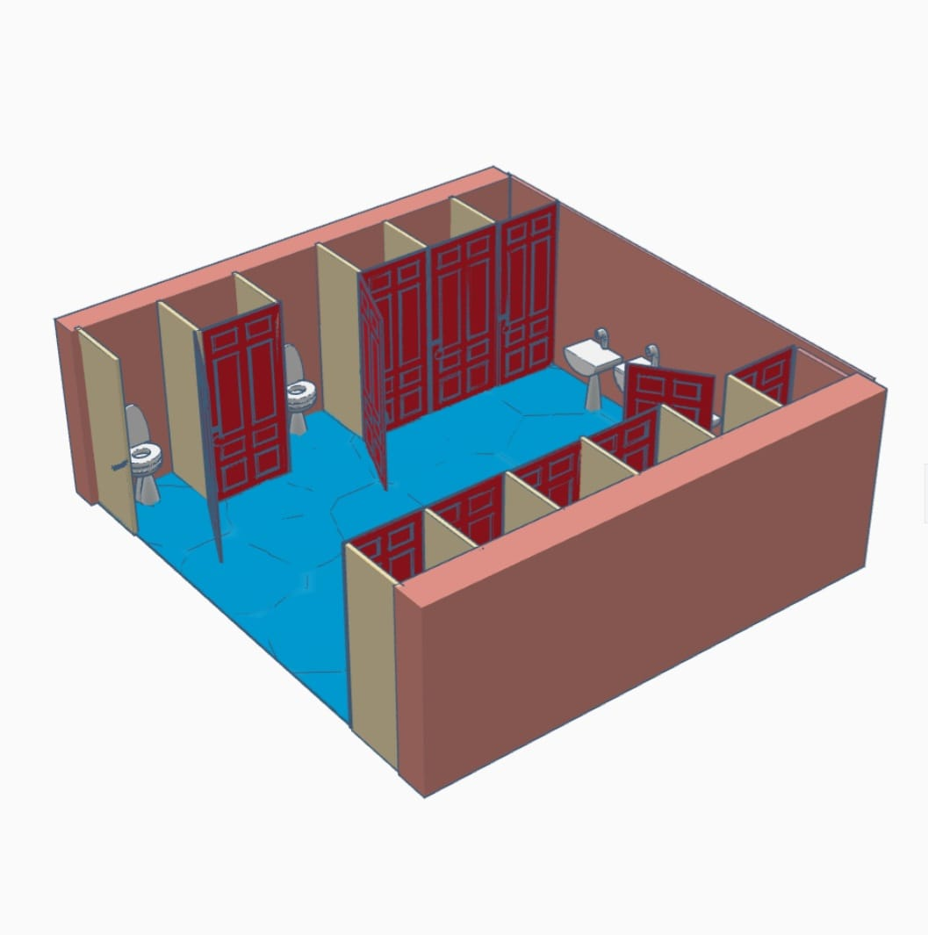

**DATA SHARING:**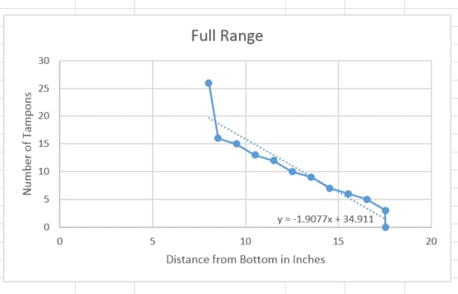

**PROJECT IN DETAIL:**

**Project Name: Smart Public Restroom IoT Project**

**Project Objectives:**

- Create a network of smart public restrooms that enhance user experience, improve hygiene, and optimize resource management.

- Provide real-time monitoring and data analysis for efficient maintenance.

- Promote sustainability through resource conservation.

- Enhance security, accessibility, and inclusivity.

- Collect and respond to user feedback for continuous improvement.

**Project Phases:**

**1. Project Initiation:**

- Project Definition: Clearly define project scope, objectives, stakeholders, and success criteria.

- Budget and Resource Planning: Allocate budget and resources for hardware, software, infrastructure, and personnel.

- Project Team Formation: Assemble a project team, including project managers, IoT experts, developers, and maintenance personnel.

**2. Requirement Analysis:**

- User Requirements: Gather requirements from end-users, including their expectations, preferences, and pain points.

- IoT Device Selection: Identify the IoT devices and sensors required for the project, considering occupancy sensors, flush sensors, soap dispensers, cameras, etc.

- Platform Requirements: Define the functional and technical requirements for the platform that will manage the IoT devices and user interfaces.

**3. Hardware Procurement:**

- IoT Device Procurement: Purchase the necessary IoT devices and sensors, ensuring compatibility and reliability.

- Renewable Energy Installation: Install solar panels and wind turbines to power the IoT devices and digital interfaces.

**4. Software Development:**

- Backend Development: Develop the backend system for data processing, analytics, and IoT device management.

- Database Design: Create a robust database structure for storing data from IoT devices and user feedback.

- Frontend Development: Design user interfaces for web-based dashboards, mobile apps, and digital signage.

**5. IoT Device Setup and Integration:**

- IoT Device Configuration: Configure the IoT devices to communicate with the central platform.

- Network Setup: Establish a reliable network connection within the restrooms for data transmission.

**6. Platform Development and Integration:**

- Platform Setup: Develop and deploy the central platform for data management, analysis, and remote control of IoT devices.

- API Development: Create APIs for communication between the IoT devices, mobile apps, and the central platform.

**7. User Engagement Features:**

- Mobile App Development: Design and develop a user-friendly mobile app with features such as restroom location finding, real-time availability, and user feedback submission.

- Digital Signage Implementation: Install digital signage displays near restroom entrances for occupancy information and user guidance.

**8. Testing and Quality Assurance:**

- Conduct rigorous testing, including functional, security, and load testing, to identify and rectify any issues.

- Ensure that the platform operates as expected and meets all defined requirements.

**9. Data Analytics and Reporting:**

- Implement data analytics and reporting tools to derive insights from restroom usage, resource consumption, and user behavior.

- Create dashboards for administrators to monitor restroom performance.

**10. Security and Privacy Compliance:**

- Enhance security measures to protect data and user privacy.

- Ensure compliance with data privacy regulations and security standards.

**11. User Training and Documentation:**

- Provide training to personnel responsible for managing and maintaining the system.

- Create comprehensive documentation for system administrators and end-users.

**12. Deployment:**

- Deploy the platform and IoT devices in the restroom facilities.

- Ensure that IoT devices are functioning correctly and transmitting data to the central platform.

**13. Maintenance and Support:**

- Establish a plan for ongoing maintenance, updates, and technical support.

- Set up mechanisms for reporting and resolving issues, and schedule regular maintenance checks.

**14. User Feedback Loop:**

- Continuously analyze user feedback data to improve the system, address issues, and enhance the user experience.

**15. Project Evaluation and Monitoring:**

- Regularly evaluate the project's performance against the defined success criteria.

- Monitor data trends, user feedback, and system reliability.

**16. Project Expansion:**

- Plan for the expansion of the project to additional restroom facilities.

- Repeat the necessary phases for each new restroom added to the project.

**17. Project Closure:**

- Document the final project status, including lessons learned and recommendations for future improvements.

- Conduct a project closure meeting to celebrate the successful completion of the Smart Public Restroom IoT project.